

**FINAL YEAR PROJECT**

***FOOD ORDERING SYSTEM***

***(3LIPAT CAFÉ)***

|  |  |  |
| --- | --- | --- |
| NAME | : | NUR SYAFIQAH BINTI KAMARUZAMAN  **(2015858166)**  NUR LYANA NADIAH BINTI MOHAMAD ROSLI  **(2015816368)**  MUHAMMAD HABIB BIN SHAMSUDIN  **(2015883868)** |
| CLASS | : | M3 CS110 5C |
| LECTURER’S NAME | : | MADAM ZAMLINA BINTI ABDULLAH |
| SUBMISSION DATE | : | 19 DECEMBER 2017 |

**TABLE OF CONTENT**

|  |  |
| --- | --- |
| **TITLE** | **PAGE** |
| INTRODUCTION | 3 |
| OBJECTIVE | 3 |
| SCOPE | 4 |
| FLOWCHART | 5 - 6 |
| DATABASE | 7 - 8 |
| INTERFACE | 9 – 17 |
| CONCLUSION | 18 |
| RECOMMENDATION | 18 |
| REFERENCE | 19 |

**Introduction**

Tiga Lipat Café is a hipster trending café that are focusing more to youngsters to hang out while having meals that followed the nowadays trend. The owner is planning to improvise their services by providing a friendly user system to ease the customer to place an order at their café. This system will also allow customers to view the menu at any time without having to ask for the waiter to give them a list of menu. Other than that, customers can easily click the button end to receive their receipt and simply pay the total amount.

The system will have 2 users which the customer and staff. As for the staff, they can simply view the list of the current order and can change the status of the order so the kitchen will easy to prepare the meals. At the end of a day, the staff can view the total sales they make for that day, the best seller in the menu and the statistic of the profit in a week.

**Objective**

* **Improve customer buying experience**.

Kiosks can provide our customers with detailed information about our products and services. Since kiosks are easily accessible, our customers will find it convenient to visit a kiosk for inquiries such as product pricing, feature comparison, etc. It will also instill confidence in our potential customers, since you are using the latest technologies to improve their buying experience.

* **To reduce cost**.

Interactive kiosks can be used in place of staff. Since we don’t have to pay a kiosk a salary, we’ll save a good amount of money. Also, since kiosks can provide our customers with answers to many of their buying concerns, we can focus our labor costs on sales professionals to further increase our total sales volume. Moreover, opting for a kiosk instead of a traditional retail space will keep our rent and overhead costs down while we still benefit from increased visibility.

* **Help save time.**

We can utilize a kiosk to assist our business operations to help save time. For example, we can have both a cashier and a kiosk helping to check out customers. This will cut waiting times by up to 50%. As a result, our customers will have a more positive experience at our store and will be more likely to return.

* **Reduce the cost of business**

A company using a retail kiosk strategy is able to offer more services at a lower cost. Because information kiosks can provide the consumer with an answer to many of their buying questions on-demand basis, it allows a store to focus on their labor costs on sales professionals that can help to increase the total sales volume for the retailer. In addition, by streamlining the total number of employees needed to service their customers, a retailer can also cut back on costly managerial resources as fewer total employee require less total management.

**Scope System**

The scope of Tiga Lipa Café Ordering Food System is divided into two user. Firstly, customer. Customer will use this system to order food. Secondly, for the staff to monitor total profit of the day.

This system will cover:

* Order list by customer
* Calculate total profit

For customer section, customer will:

* Enter name
* Enter number of person
* Choose to dine in or dine out
* Choose menu

eg: Food, drinks, dessert

* Receive bill information ( receipt )

For staff section, staff can:

* View the total of profit for all menus
* View the total of profit for each menu
* View list order from customers
* Update price and name of the menus
* Delete list of order from customers

**Flowchart ( Staff )**

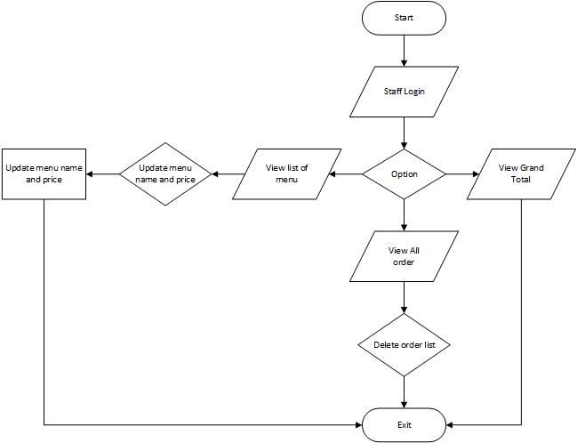

**Flowchart ( Customer )**

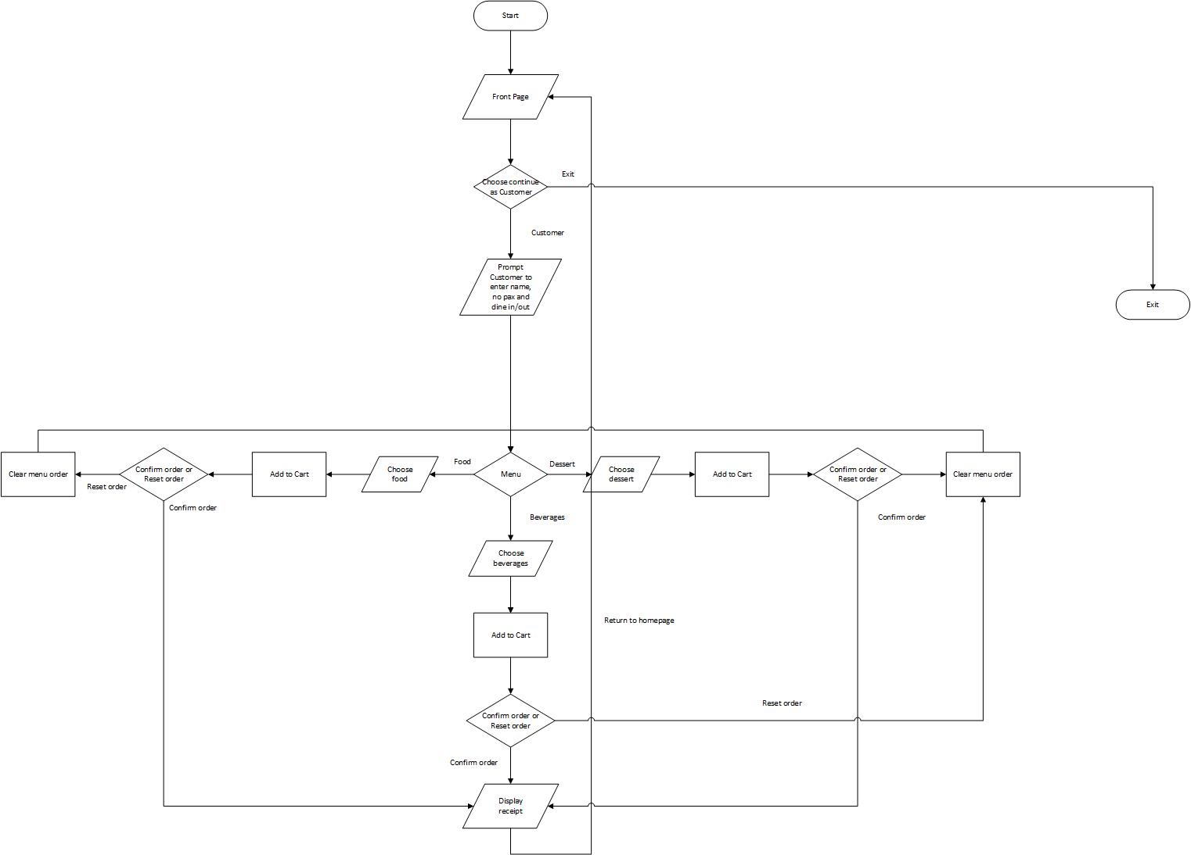

**Database**

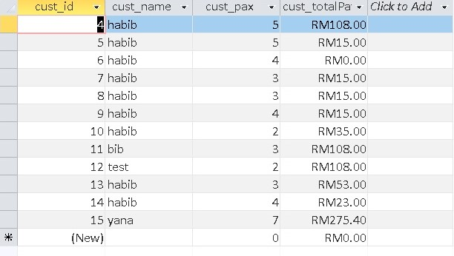

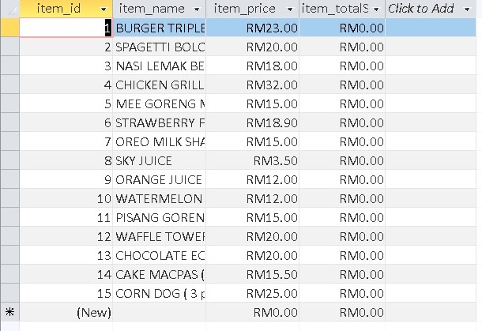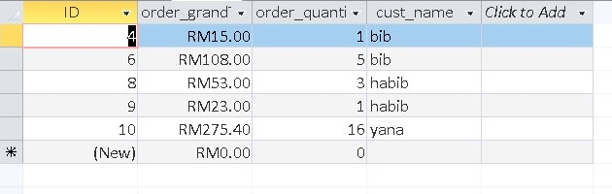

**Interface**

**( CUSTOMER’S INTERFACE )**

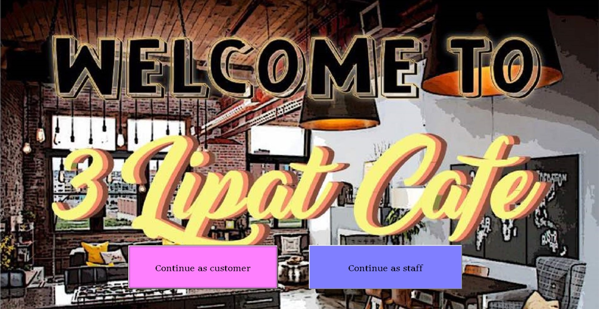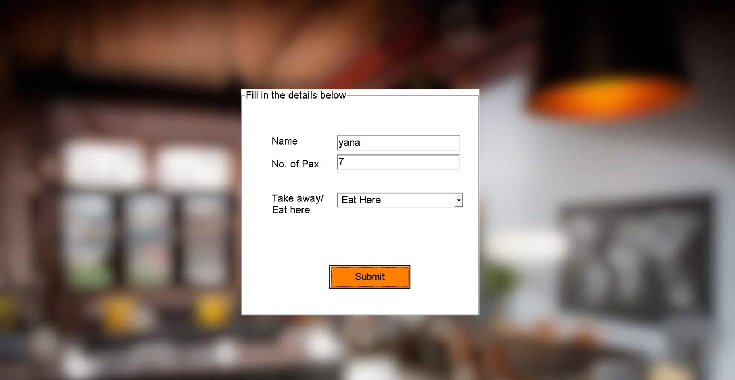

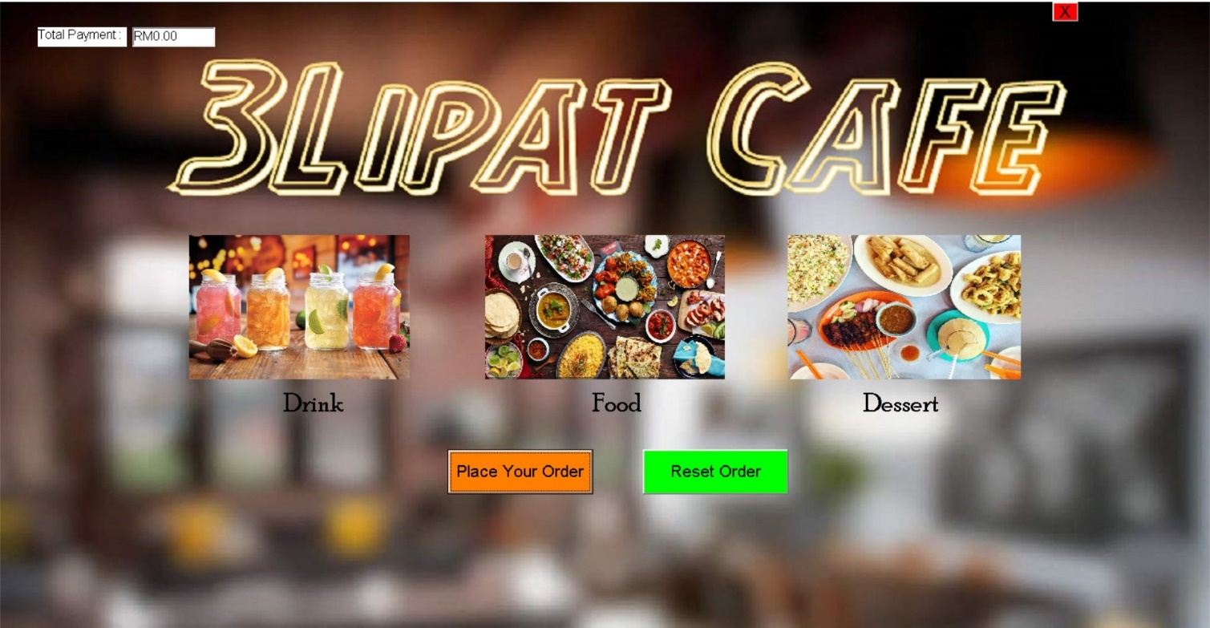

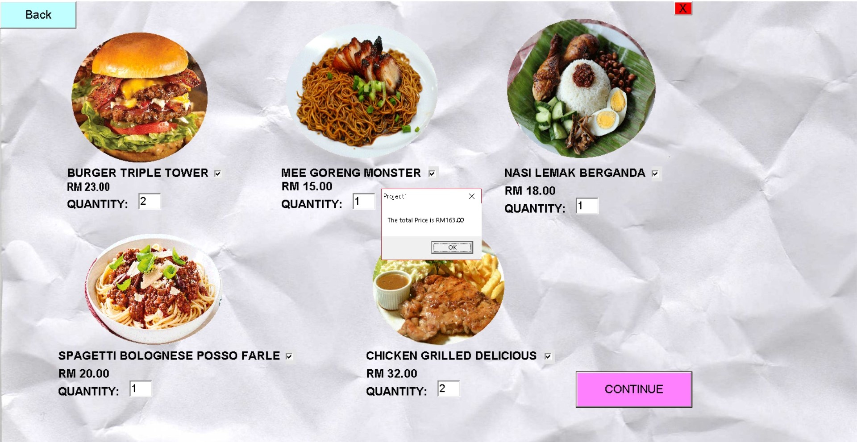

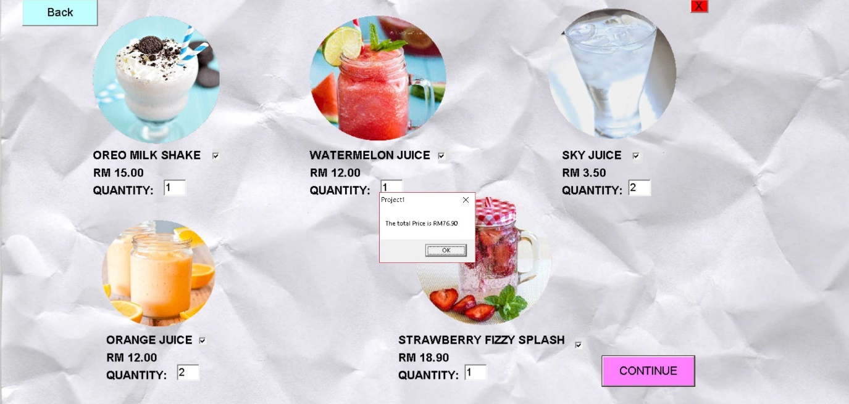

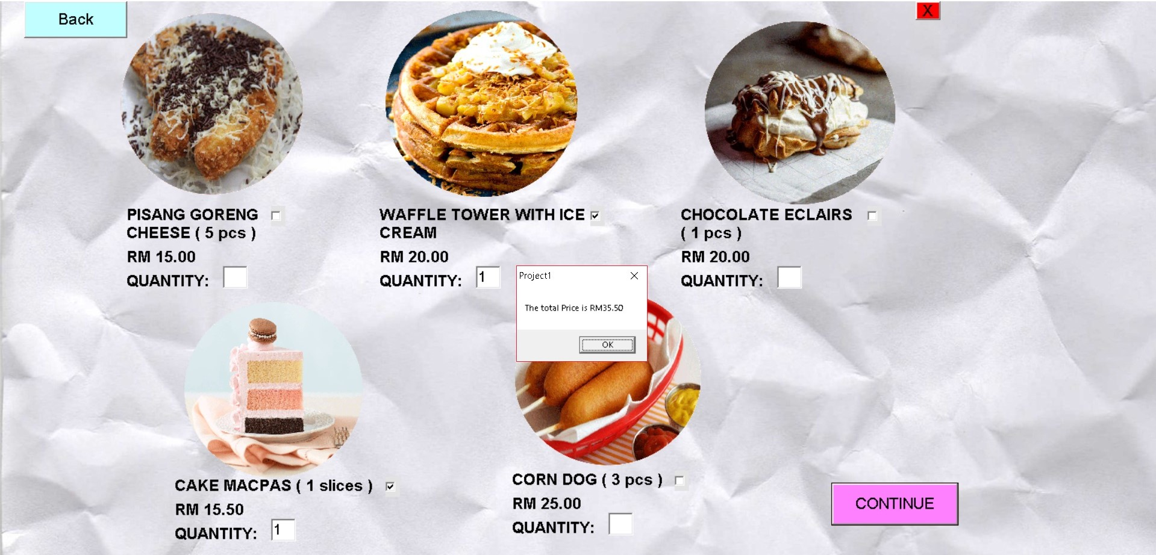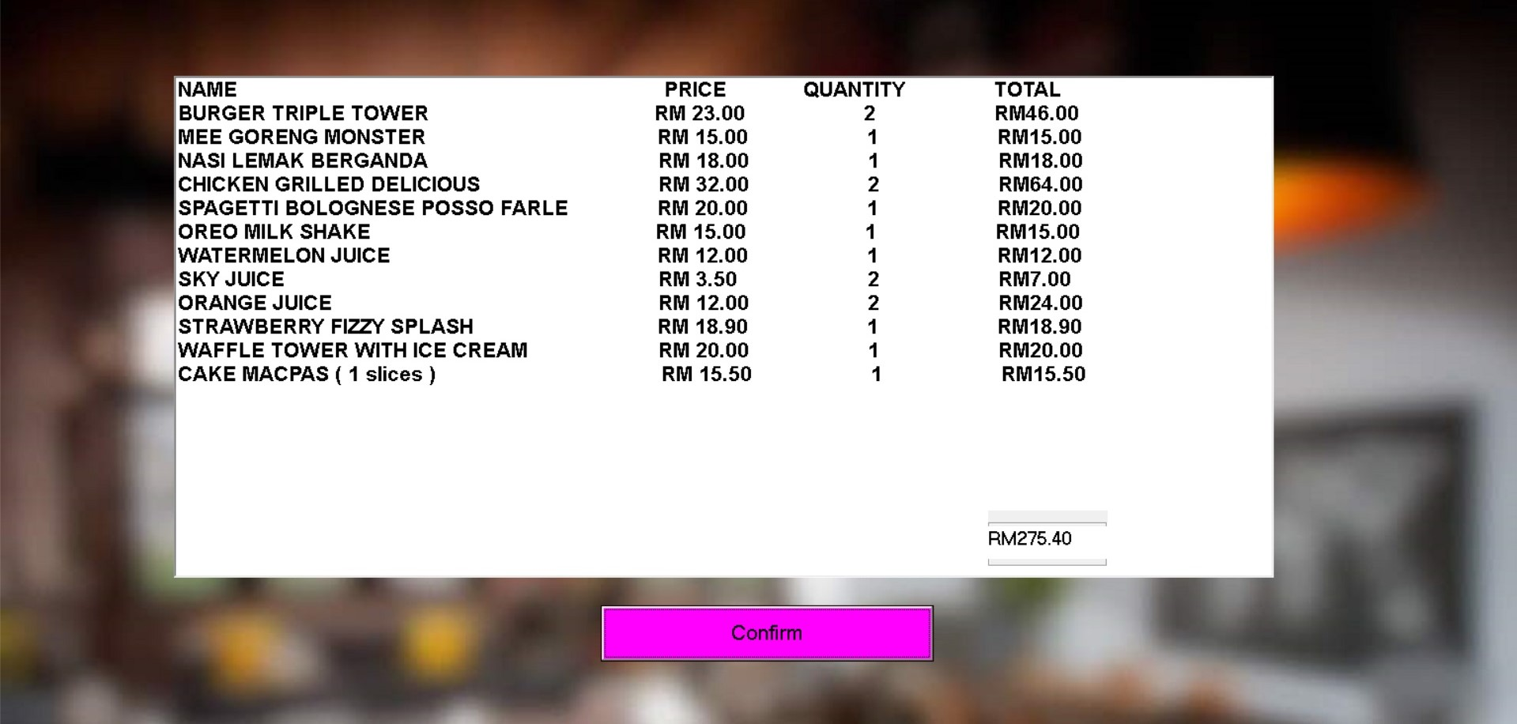

**( CUSTOMER’S INTERFACE )**

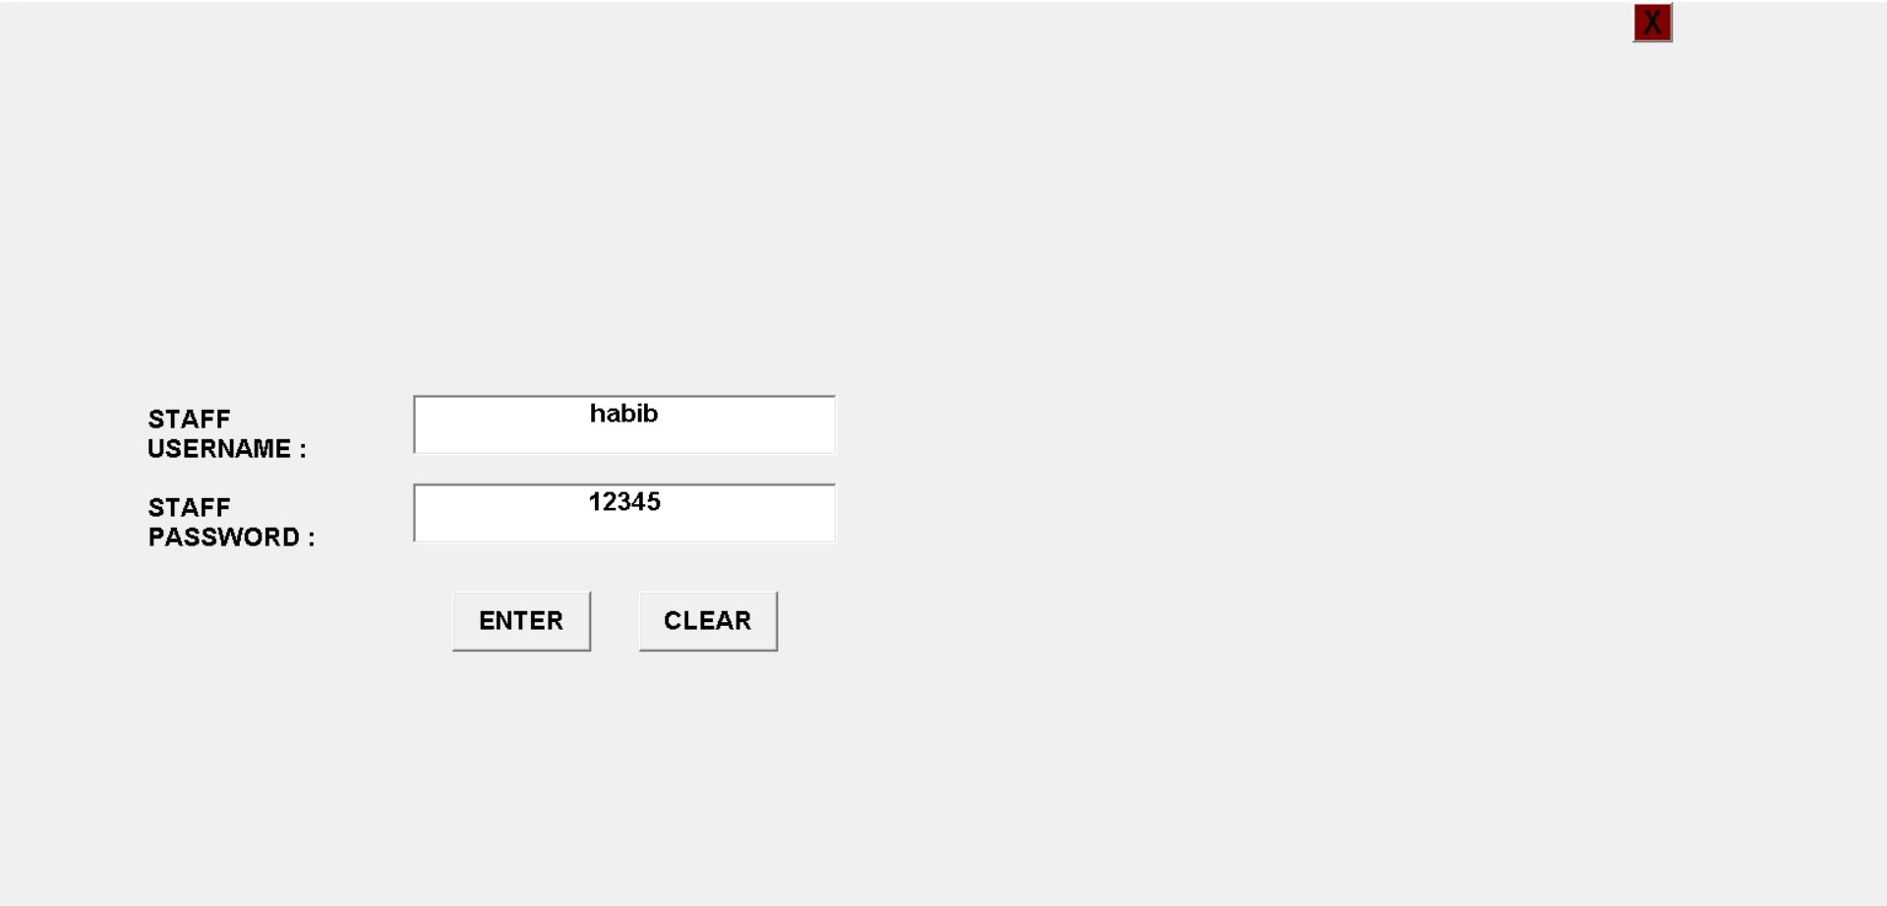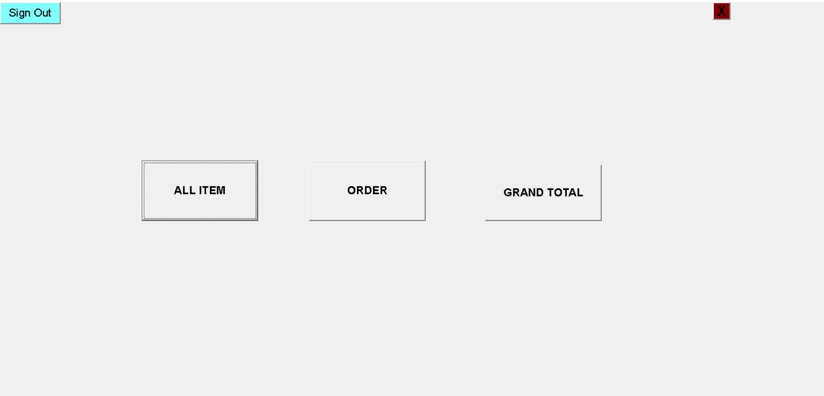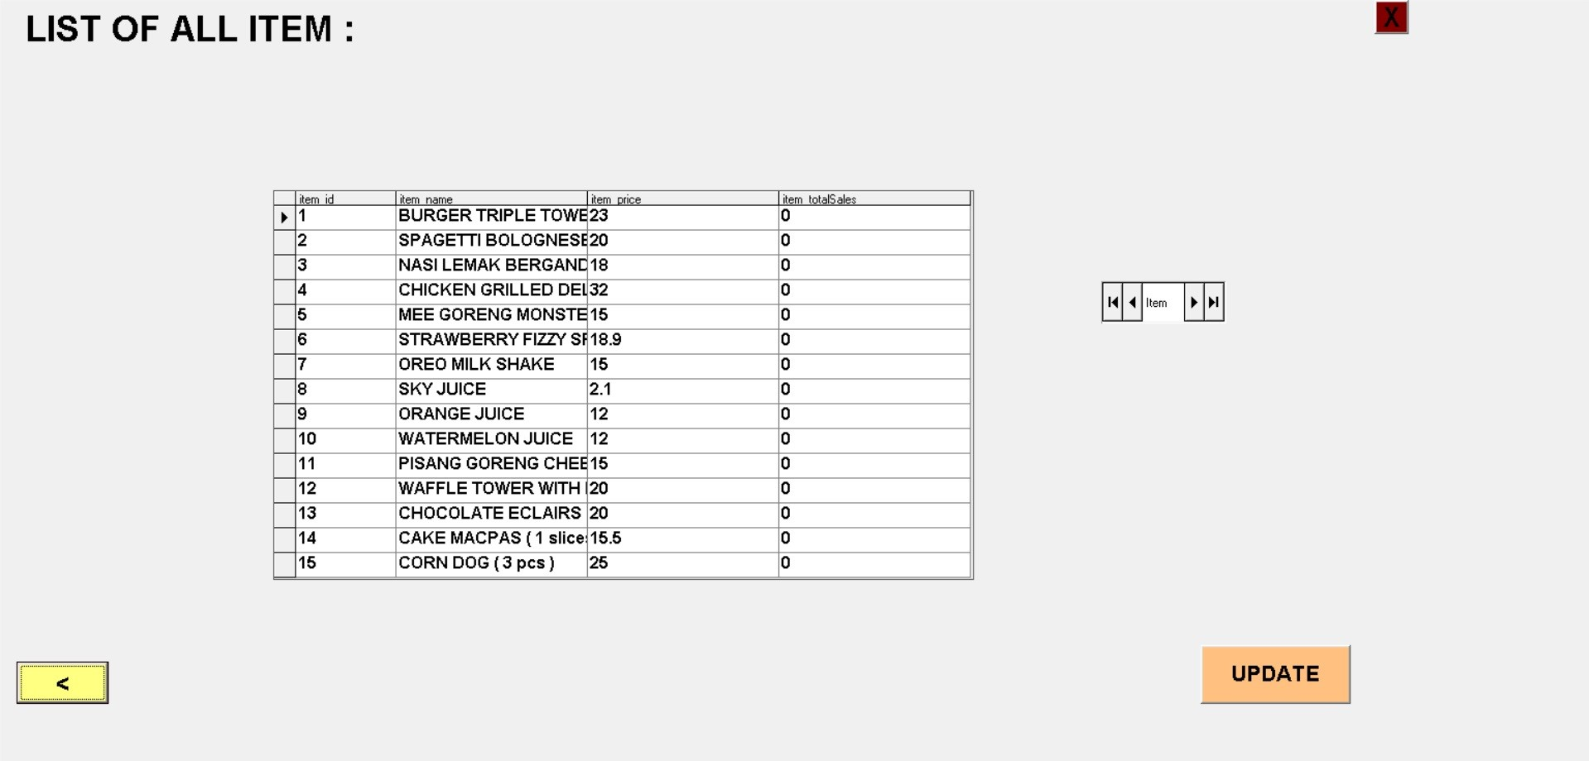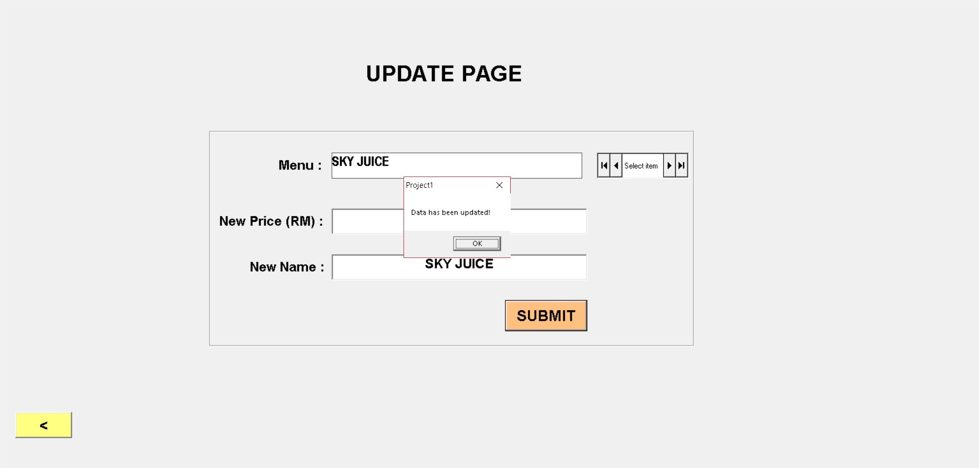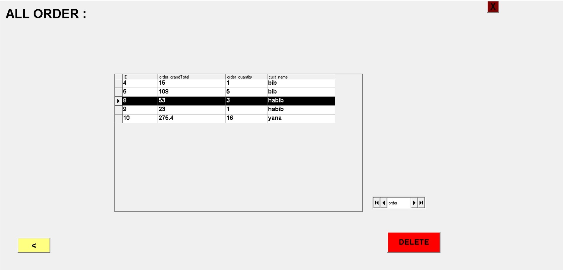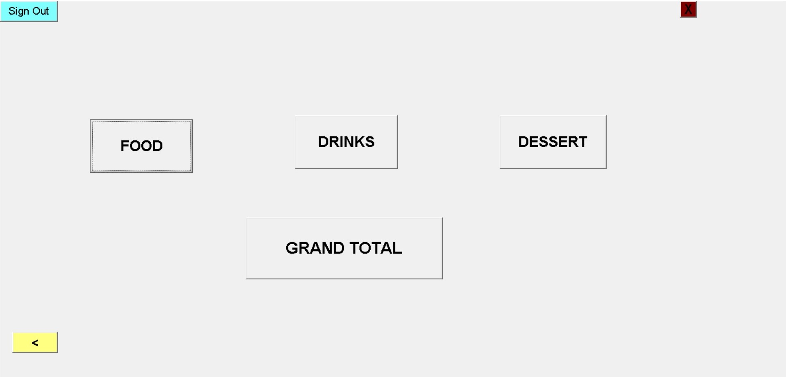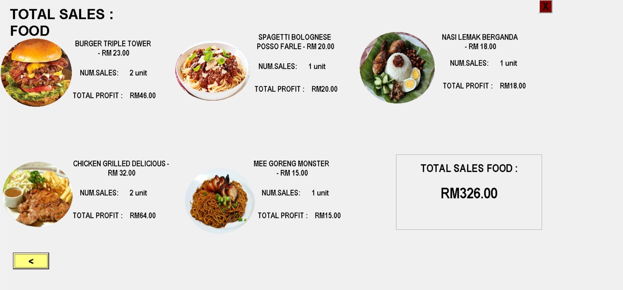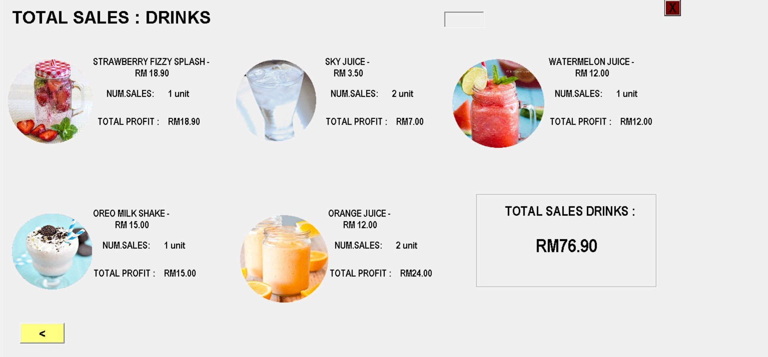

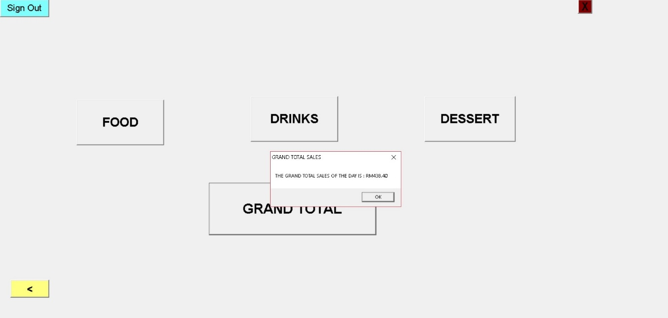

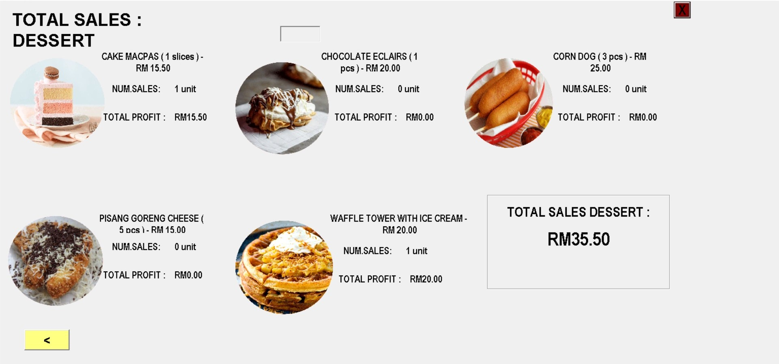

**Conclusion**

To be conclude, our systems covers both side of user which customer and staff. Customers who came to 3Lipat Café will have an efficient service since they don’t have to wait for waiters to take their orders. They can directly order through our system efficiently and at ease. It is easier for them to view our menu that available in our café with price respectively.

On the other hand, 3Lipat owner will have advantage of saving cost since they do not have to manage many staff since they only need few of them in the kitchen and as casher. They can view and keep track of their business easily since the data that has been entered by the customers will be stored safely in the database. Managers of 3Lipat can easily save it as softcopy in the folder or can also print it out and keep it in files.

**Recommendation**

1. **Use a different database**

Currently, we are using Microsoft access to store our data of customer. We faced problem in the process of creating database and storing the data in the database. It will be more practical if we use PhPMyAdmin as our database cause it will be more easier to store and retrieve data.

1. **To able the staff to search any information to ease their research**

Currently, our staff have to manually search from the button that we have provided. They have to go through each of the data they look for. If there is button search,it will make the searching process easier and save time.

1. **Able the staff to add new menu**

Our staff cannot add new menu into the system. It has to be added manually by the admin or programmer by adding it in our interfaces.

1. **Able the staff to add or update new pictures of the menu**

Our staffs are not able to insert or update new pictures to the menu if they wanted to change the picture cause they have to manually insert it in the interface or designing phase.

**Reference**

1. Madam Zamlina Binti Abdullah

Lecturer of Visual Programming CSC301, M3CS110 5 C

1. [www.vbForums.com](http://www.vbForums.com)
2. Visual Basic 6.0